                                                                                                                                                                         NAME OF THE COMPANY: GROOVE BOOK







                                                                                     By:  Sneha Palvai

Reason for selecting Groove Book:

Now-a-days everyone has feasibility in access to mobile phones and capturing pictures of our best moments.Our team have decided to select the project of Groove Book after viewing the latest episode of shark Tank of Groove Book hired by shutterfly for 14.5million dollars. After we had reviewed about this Groove book, we really found this very interesting as it seemed to be very reliable and affordable at such a lower price for all the users.

Co-Founders: Julie and Brian Whiteman



Initial Investor at Shark Tank: Kevin O’Leary invested $150k for printing photo books from mobile phones by which their stake improved upto 15 times after this show.

Found Investor at shark Tank : Shutterfly Inc. owned Groovebook for 14.5 million dollars.

Specifications:

* This is one of the app which can be downloaded in any mobile device.
* Can upload upto 100 photos from our device per month.
* Can print hundred photos each of 4x6 size every month.
* Free shipping.

Reference: [<https://www.groovebook.com>]

Background History:

GrooveBook co-founders Julie and Brian Whiteman were really disappointed as they lost their family pictures from their mobile. As Brian Whiteman was passionate about photography, this made them to think and propose the idea of Groove book. They got to know about shark Tank, by Brian’s Mother which encouraged them to get connected to Shark Tank to get a wide range of national exposure and investor-backing for their Groovebook. I think this is so unique as it is groove shaped, photo album can be easily bended and twisted and can be easily enclosed in a small shipping package which only costs $0.80 and also most of them (almost everyone) uses mobile phones in this generation, which makes them easier to download groovebook app free of cost. In addition to that everyone would enjoy to save their best memories in the form of  pictures. Based on this consideration factor and requirement, came into existence of Groovebook which can take printouts of 100 photos every month for such a great deal of $2.99 which includes the special offer of shipping too. Who would even go other options, if they are getting such a best deal.

Initially Kevin O’Leary invested $150k for printing photo books from mobile phones by which their stake improved upto 15 times after this show. More than 1 million subscribed and more than 200 million photos were uploaded. Everyone would love this and as expected success rate increased spontaneously which Shutterfly Inc. was very impressive and was immediately purchased for 14.5 million dollars.

The new resources which we think  required are

* Advanced machineries to print photo copies
* Web management to add all the subscribed customers list.

Reference: [Episode-13 season5 in shark Tank show]

Latest Update on GrooveBook:

There seemed to be an impressive demand in this scale by triple percent after this show. There was a rapid increase in number of subscriptions which led to their success. In November 18th 2014, Groovebook was owned by Shutterfly Inc for an amazing worthful deal of $14.5 million which is a grand success in the Shark Tank show. Groovebook deal is the largest deal in shark tank history.

Shipping expenses:

Groovebook can be shipped at $0.80 each which is absolutely the best deal. groove on the book is an amazing idea which has become one of the most significant competent feature than any others. Neither anyone could compete to make and ship a photo book named groove book with 100 photos at such a low price.

Reference:

[<http://abc.go.com/shows/shark-tank/news/updates/20150130-groovebook-sells-to-shutterfly>]

For example, If we invest a business with  $150k, we need a printing company which should be invested for $100k and me may need few computers say around 5 well advanced technology based computers which can have access to photos and one main system holding all details of receiving and sender orders which can be managed by one main database administrator. Few employees say around 10 staff members are enough for this to make sure everything is done appropriately by handling all the devices in printing, delivering, packing,etc. The ratio of  customers increases eventually. If customers increased  rate is ten times more with in 5 to 8 months then  it’s little difficult to handle with this expected assumption requirements. We then have to look for good investors like shutterfly for funding us.

Here we come across 4 different types of users in handling this Groovebook. They are:

* Admins: We can organize the admin by hiring an employee who can handle all the activities by representing in the form of  data  and therefore a website is needed to support the customer interactions and order processing
* Suppliers: Needs employers for supplying photobooks to all the specified ordered customers and therefore a supplier is needed to check and handle all the supplies to reach them to customers.
* Employees: Few employees are required for printing the photos and arrange them accordingly.
* Customers: Normal people who subscribe for this groovebook. The customers access the website for online purchases.

All the above information is explained in detailed further discussions.

Funding approach in Shark Tank:

Julie and Brian approached Shark `Tank expecting $150k for 20% of their business. All the sharks were really happy when they heard of subscribing 18,000 members initially in past 8 months which they think it’s really an amazing subscription service. But initially, they were quite hesitant to invest as GrooveBook cost $2.30 and they only get 69 cents per order for which they think it’s too low to make good amount of money. But they really like their innovative idea as it seemed to increase its demand for subscriptions enormously.

We considered a company whose initial budget is $150k

Hardware & Software requirements:

Android and IOS Mobile devices used by customers:

All versions of apple iphone and all android mobile phones support downloading grooveBook app in their devices. The main intention of this Groove Book product is to ensure that it should be affordable by a common man too. Keeping this in mind GrooveBook app should be built in such a way that it can be installed free of cost in all devices by all the customers.

Size**:** Size of GrooveBook should be 4 x 6.  Only this size is chosen because it is easier to ship at minimum cost.

Design: Groove in the spine

While designing the book, it should be kept in mind that there should be a groove in the spine as it makes each book flexible and can be shipped to customers with the best cheapest deal of $0.80 each. We think this is really a great idea of having groove, otherwise shipping charges would have been $3 - $4 each which should have been one of the drawback.

Computer specifications: As per our estimation we require 5 advanced computers to gather and download all photos uploaded by customers. We chose 2016 Newest Dell Inspiron 23.8” Touchscreen All in One Desktop Full HD (1920 x 1080), 6th Intel i7-6700T Processor 3.6Ghz, 12GB RAM, 1TB Hard Drive, DVD Burner, WiFi/HDMI/Bluetooth/Webcam, Windows 10 each costs $850.00. So the total cost for 5 computers will be $4250.

3 computers for employees, one for system administrator and the other is for project admin/owner.

Advanced printing machinery requirements: We require at least 15 printers in order to print the photo copies with below specifications HP  Envy 7640 Wireless All-in- One Photo Printer with Mobile Printing, Instant Ink ready( E4w43A) each costs for $68.00. So the total cost for 15 computers will be $1020. In addition to that we may require at least  2000 of HP Advanced Photo Paper, Glossy (4 x 6 inches, 50 sheets) borderless  each costs $7.99. It takes about $15.5k to satisfy 1000 customers. Depending on the increase of subscriptions, the requirement of this paper increases.Here subscriptions based services and Groove-book’s printing are entirely dependent on each other. GrooveBook printing can be done in a small print shop. So, it is very important for us to tie up with some printing company for investing us. we may have to make a best deal with photoshop company like shutterfly which help us in printing the customer’s uploaded photos.

Printing expenses: It takes $1.49 to print each book which has perforated photos printed on a book which is perfect for fitting in frames. Initially this can be done in a small print shop like Digital and Lithographic print company, screen print company, etc. Printing at such a cheaper rate is the most attractive feature of this. This is one of the most attractive uniqueness to be considered.

Reference:[<http://www.namestation.com/printing-company-names>]

Estimated profit:Each customer’s subscribes this product at $2.99 for which after deduction of making+shipping charges, the estimated profit on each book is $0.70. We understand that the profit margin on each book is too low, but our aim is to grasp attention of all the customers to subscribe this product at such a low price which is affordable by everyone. We are sure within few months everyone would download this app and the subscription rate increases to some millions of customers which gives a remarkable profit overall.

Reference: [<http://www.forbes.com/sites/amitchowdhry/2014/11/18/shutterfly-acquires-groovebook/#8352d2a4925d>]

Web Management:A well operating database administrator who can safely store all the information of subscribed customers is required entirely operated/ saved in a server. We need a well efficient administrator who can handle server and at the same time he should be able to manage all the data is stored in one place and also retrieve back in future if we want to recheck

We can estimate the pay to be little high to administrator as $2k monthly.

He controls online customer login /app login

The server stores all the information of the customer details.

Employers:

We require minimum of 4 employees to assist in printing

First employee:For printing

Second employee:For organizing a groovebook

Third employee:For shipping

Fourth employee: for checking status.

Per day each person pay is 60$, overall estimation of all employees salary is 7200$ per month

We are not planning to move our business to cloud service as it takes additional amount and also we started with a little budget. Initially we are looking forward to grab attention of all the users to subscribe with us with such a low price.We will implement cloud service randomly with increase in subscriptions.

Data Storage Selection:

In our company, we may need data storage mainly for the following reasons:

* To save customers data in terms of their address and their full name.
* Adding updated online subscriptions made by new customers.
* For storing employees details like their full names, age and payroll services.
* To store the details of received and delivered orders.
* To store this entire entity in a web management.

Our selection of Data Storage:

The need to use application software as well as support software is essential in our company.

Since GrooveBook initial budget is too low, our main motive is to attract customers by making them easily subscribe towards our groovebook. One of the smartest, cheapest and efficient way is that we make use of few computer based application softwares like Microsoft Excel to store/save details of customers. we have chosen a small database management system in terms of handling data storage.

Reference:  <https://rivier.instructure.com/courses/1806343/files/folder/Slides/Week_02?preview=95802402> Reason for choosing:

Excel itself is sufficient for storing customer’s details, but it becomes more difficult to handle and manage huge data to add, update,delete and retrieve data. We need sequential file storage as we need to store the uploaded photos from customers and their details should be saved sequentially so the it makes easier for us to implement rest of the things.So, we chose Database management system, which is much more flexible and reliable for following reasons:

* Save subscribed customers list.
* Store all the required information.
* Update address change or details of same customers
* Add new customers to the list.
* Delete unsubscribed customers form the existing list.
* Searching makes easier by simply using a reference index number/key.

Data management system GUI’s can be handled in a SQL server management with the help of a tool called PgAdmin III (free to download). we need a reasonable cost support software like SQL Server which functions in the back end without direct interaction from customers.

Reference:[<https://rivier.instructure.com/courses/1806343/files/folder/Slides/Week_02?preview=95802402> ]

PgAdmin 4 v1.1( Free):

PgAdmin 4 v1.1 is very reliable and open source administration and development platform for PostgreSQL. This can easily run on our Windows OS computers in our company. We chose to use PostgreSQL as the RDBMS. PgAdmin has features which fulfills the needs of all the users from the initial stage of writing simple queries to final stage of developing any of the database which is very complex to handle. Also it’s a free software under PostgreSQL License.

Reference:

[<https://www.pgadmin.org/> ]

[https://www.pgadmin.org/licence.php]

Comparisons with other alternatives:

(i) The other alternatives in handling data may be done in random access file management system too. But in our company, we only need an external hard drive as we have to save our photos first,and save customers list final stage comes to implementation part i,e; printing and shipping. The final stage doesn’t fall under data storage. So by considering only the fact of saving and uploading it is economic for us to use sequential data storage access.

(ii) PgAdmin 4 v1.1 is free than any other existing licensed Microsoft SQL server, Microsoft NOSQL server  which is much costlier. The price ranges is shown in the following links:

<https://www.google.com/webhp?sourceid=chrome-instant&rlz=1C1CHWA_enUS703US703&ion=1&espv=2&ie=UTF-8#q=Microsoft+SQL+server+cost>

<https://www.microsoftstore.com/store/msusa/en_US/pdp/SQL-Server-2016-Standard-Edition/productID.1925832000>.

Networking Plan:

Our’s is a small company with only 5 computers, information can be moved to hard disk. Each of specifications 2016 Newest Dell Inspiron 23.8” Touchscreen All in One Desktop Full HD (1920 x 1080), 6th Intel i7-6700T Processor 3.6Ghz, 12GB RAM, 1TB Hard Drive, DVD Burner, WiFi/HDMI/Bluetooth/Webcam, Windows 10.

Reference:

[<https://www.google.com/webhp?sourceid=chrome-instant&rlz=1C1CHWA_enUS703US703&ion=1&espv=2&ie=UTF-8#q=2016+Newest+Dell+Inspiron+23.8%E2%80%9D+Touchscreen+All+in+One+Desktop+Full+HD+(1920+x+1080)%2C+6th+Intel+i7-6700T+Processor+3.6Ghz%2C+12GB+RAM%2C+1TB+Hard+Drive%2C+DVD+Burner%2C+WiFi%2FHDMI%2FBluetooth%2FWebcam%2C+Windows+10>]

These 5 computers can be networked together in a bus topology as it’s much more cheaper, reliable and best for limited computers. A single ethernet cable of  10Base-2 or 10Base-5 can be used to join all the PC’s together. We understand there are certain limitations for bus topology, but since we only have five desktops we can easily rectify the failure if one system fails. We chose this bus topology as this is less prone to failure and well economic factor.

Reference:[ <https://www.lifewire.com/computer-network-topology-817884>]

Internet Service Provider:

We only require an internal home network like Xfinity service provider. We chose this as we personally use this network in our home too. We think this can be the best deal for our company as we mostly need internet to access the uploaded photos of customers and verify their details.

Router not required:

A Router 2 Model Numbers: DPC3939, TC8706C with Dual-Band Wifi 2.4 & 5GHZ, 802.11 ac is required to create secured for both wired or wireless home network. So, additional router is not required.

Reference:

[<http://media2.comcast.net/anon.comcastonline2/support/userguides/HOW5220_FINAL_ENG_WG2XB3_QSG_0713_IG.pdf>]

Service Contract:

Xfinity is not a service based contract. We can make monthly payment by choosing XFINITY Starter XF Double Play $69.99 each month for 24months.

Reference:

[<http://xfinityspecial.com/double-plays.php?PID=google_branded:xfinity_internet_packages:Xfinity_Mid_Tier_Performers:Xfinity_Internet_Packages&gclid=CjwKEAiAsMXBBRD71KWOh6fcjRwSJAC5CNE1i1-SrTjN1uighT_ur3rBv6N9XrQn_SHfmlAuxKq81xoCt_3w_wcB>]

Vendor Systems:

We require several supporting systems for any company in order to make it a successful one  in this competent generation. For our GrooveBook company is a small company, in which we need some system which is very helpful to manage and handle few back office functions related to services, technology and human resources. Initially the  need for us to focus on the  following below details is very essential:

* How to plan the design of our GrooveBook should be?
* How to develop the GrooveBook product?
* How can it be manufactured?
* How does sales rate can be increased?
* How the marketing can be done?

These all required factors including product planning, development, manufacturing, sales and marketing are included in ERP which inspired us to choose small business Enterprise Resource Planning which is part of Odoo ERP.

Source:( Enterprise Apps Today; ERP Buyer's Guide for Small Businesses; Drew Robb)  
A proper planning is much more essential in order to enhance the inbuilt functionalities of sale and marketing skills. ERP planning helped us to properly plan our product by which we were able to decide it’s  groove shaped and 4x6 photo size. Since ERP is the integrated management of core business process,often mediated by software & technology . these business activities may include business planning,manufacturing, marketing,sale etc. This helped in planning the design to be groove shaped as it explained us all the scenarios of shipping charges. Their planning suggestion helped us to go for groove shaped.It also gave us the idea of using printing machines for manufacturing these groovebooks keeping in mind of cost requirements. More details of choosing ERP is explained in the below paragraph.

Reference:[ <http://www.webopedia.com/TERM/E/ERP.html>]

[[https://en.wikipedia.org/wiki/Enterprise_resource_planning](https://en.wikipedia.org/wiki/Enterprise_resource_planning)]

Software selected: ERP, Odoo software

We tend to use ERP, Odoo software because in this we can make our own choice of purchasing   individual software modules depending on our requirement. In our company, the need to manage back office activities like storing all the information of customers, their address details, delivery details and saving uploaded photos is required. In addition to that we also need ERP software to handle:

* Distribution supply chain management
* Material purchasing
* Prices & to improve financial data
* Automate employee payroll life cycle
* To minimize redundant tasks
* Accounting and financial applications
* Manage human resources and payroll
* To meet business needs
* Estimation of profit and loss analysis.

All these necessities for our company can be efficiently handled by ERP software.

Reference:[ <http://www.webopedia.com/TERM/E/ERP.html>]

Advantages for choosing Odoo ERP:

By selecting our own software module, we can minimize our budget to certain aspects based on our requirement. Odoo ERP is mainly a suite of open source enterprise management applications which is available free of cost.All these can be properly managed:

* Billing & warehouse management
* Material purchasing (like Paper, printing machines, computers etc)
* Prices which improve sales and subscriptions( minimum of $2.99 per groovebook attracts everyone).
* Minimizing redundant tasks like avoiding doing same task multiple times without proper acknowledgment.
* Accounting and financial applications can be properly balanced.
* Managing human resources and payroll in order to pay employees.
* Profit and loss analysis can be estimated to meet business requirements.

Reference:[ [https://en.wikipedia.org/wiki/Odoo](https://en.wikipedia.org/wiki/Odoo))]

Disadvantages of opting other methods:

Unlike other alternative vendor companies like:

Netsuite ERP: Netsuite is mostly useful for cloud-based business management and is mainly designed for extensively wide range of industries which has a service of Enterprise Resource Planning( ERP) and customer relationship management (CRM) functions. This is not worthful for small companies as it is expensive to be implemented. At present, our Groovebook company however doesn’t require cloud based business management.

Reference:[ <http://www.netsuite.com/portal/products/erp.shtml>]

Oracle ERP: Consists of CRM and supply chain management (SCM) applications developed by oracle which is again expensive.

Reference:[<https://en.wikipedia.org/wiki/Oracle_Applications>]

Odoo ERP: Microsoft ERP these are reliable approach for higher level companies.

Since GrooveBook company is a small company starting with low budget, Odoo ERP is best choice for us allowing all the necessary features at free of cost.

Activity diagram for customers placing order using GrooveBook app:

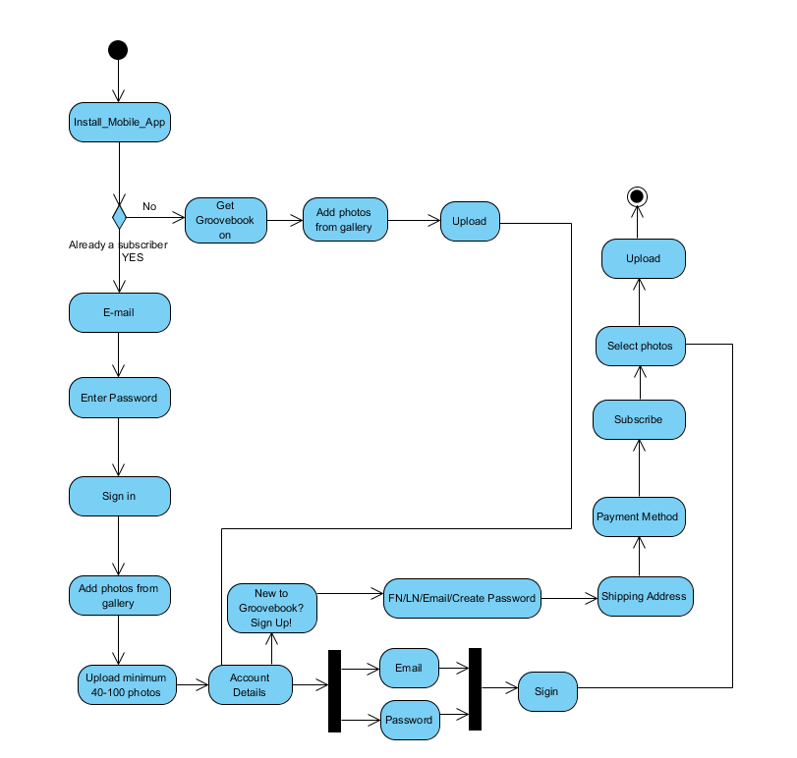

Description:

Install Mobile app: Customers downloads groovebook app in his/her mobile device.

If he is already a subscriber (YES):

Email, password & sign in: They just have to enter  their email and password details in order to sign in.

Add photos from gallery(40-100 photos):  He can directly add 40 to 100 photos per month from his gallery.

Account details: Once photos are uploaded, they need to give their account details by entering email and password

Select photos: Customers can choose their favourite pics from their mobile.

Upload: Photos will be uploaded finally.

If he is not a subscriber (NO):

Get groovebook on: They need to get groove book on his device and add photos from gallery.

New to groovebook: User needs to sign in by creating an account with first name and last name.

Shipping Address: Enter shipping details and can upload pictures.

Payment method: In this customer can add their credit card details.Once the limit reaches to 100, the photos will be uploaded and closed. in order sign in by adding his credit/ debit card for payment.

Subscribe: Now customer will be able to subscribe, select photos and upload.

Activity diagram for limit condition in uploading pictures:

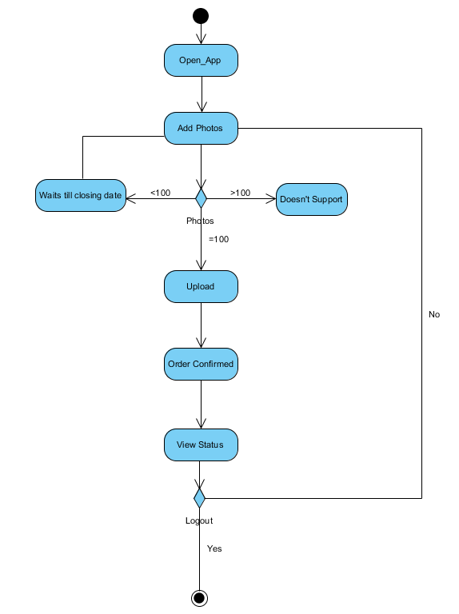

Description:

Open app: From customers point of view, they only have to open application initially.

Add Photos: Add not more than 100 photos from their device.

Photos Limit condition per month:

< 100 photos:If less than 100 photos, it waits till closing date and closes after that.

> 100 photos: He cannot upload more than 100 pictures per month.

= 100 photos: Photos will be uploaded as it reached to maximum of only 100 photos per month.

Order confirmed: The order is confirmed once photos are uploaded for that month.

Check status: They can check  status if necessary.

Add photos for next month: They can add photos for next month and process flows the same way again.

   UML Diagram of GrooveBook System:

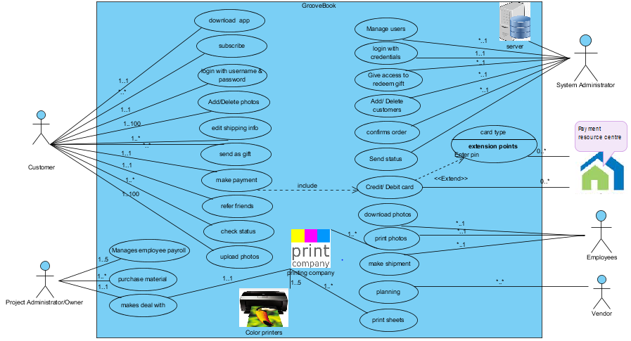

Description of Use case diagram( GrooveBook System):

In the below use case diagram,  we have considered the entire system as Groovebook system. We also included some images which are not a part of use case, just trying to represent with few images taken from google to look little different. There are 5 actors in this diagram.

* Customers
* System administrator
* Project administrator/owner
* Employees
* Vendor

Customers: Initially customers has to download groovebook app in his android device. If he needs a groovebook product, he need to be subscribe by giving few details like username and password providing their shipping details. Once they login with their credentials they are eligible to add/delete photos. They can refer friends and also can send their photocopy as gift by editing shipping details. They need to make payment with help of credit/debit card. Customers can view the delivery status which will be managed by system admin.

Download app: User can download app on his device.

Subscribe: User can subscribe

Login: Users can login with his username and password.

Edit shipping info: They have the option to update changes in  shipping info.

Refer friend: They can refer friends

Send gift: They can send gifts to their family members, friends etc by editing shipping info.

Make Payment: They can enter their credit/ debit card details for payment.

Check status: They can check their status in order history.

System Administrator: System administrator is mainly responsible for managing all the users by adding new customers as they subscribe. He can also delete once they unsubscribe.  Once the maximum limit reaches to 100 photos, it will be acknowledged by system admin, the groovebook order gets confirmed and will be ready to be printed  and shipped by employees in a printing company. He updates the status.

Printing company: This has color printers and perforated sheets which plays a key role in printing photos.

Employees: Employees are responsible for printing on a sheet with the help of color printers , packing and shipping the groovebook.

Vendor: They provide planning and manufacturing material.

Project Admin/ Owner: He pays employees, purchases all the required manufacturing material, makes deal with printing company by offering some profit percentage to them.

Use case diagram for GrooveBook application:

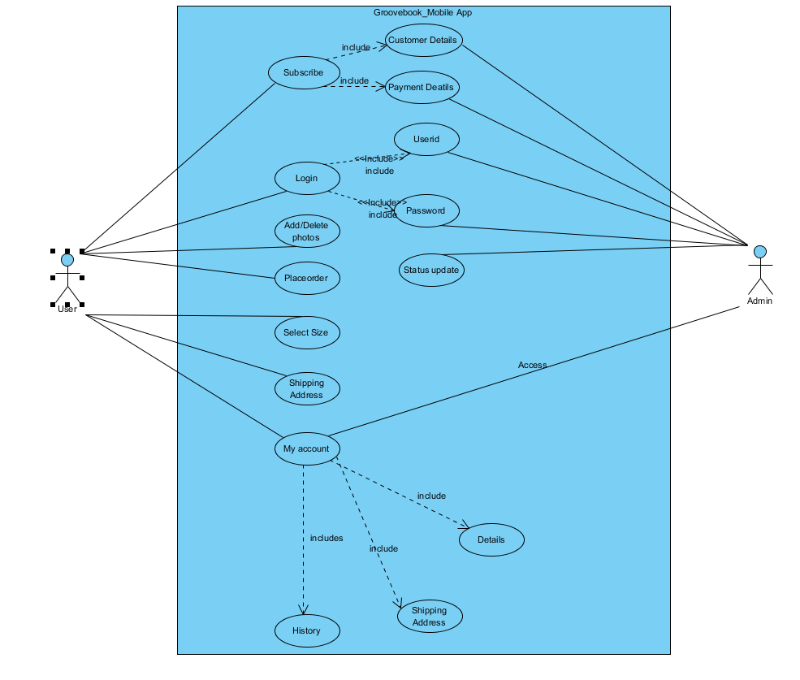

Description:

User: User will be able to lo login only if he gives proper authentication. If he enters a wrong username/password he won’t be able to login. Once he logs in he can upload form minimum to maximum photos. He have the choice of selecting and deselecting the uploaded photos till the next closing date is declared. Not only that he can select the size of photo frames too by paying little extra amount for a larger photo size book too. In My Account customer will be able to view his ordered list or check status in History. In shipping address, customers can edit his shipping information if required.

Admin: Admin manages and updates customers details once they subscribe their payment and personal details. He makes sure that everything is done in a secure way. Once they upload images, he sends the status to customers.

Things we learnt:

We really enjoyed and learnt many things in our GrooveBook - IT project. As a beginner, we gained knowledge on the following aspects:

* Using google docs
* Exploring many shark tank episodes
* Estimation of appropriate hardware requirements for an IT set up.
* Project Plan in choosing vendors
* Use case diagrams
* Activity diagrams
* Presenting in Google slides
* Usage of proper Citations
* Managing entire company with low budget
* Profit and loss estimation in a company

Main References for GrooveBook:

<https://www.groovebook.com>

<http://www.netsuite.com/portal/products/erp.shtml>

[https://en.wikipedia.org/wiki/Odoo](https://en.wikipedia.org/wiki/Odoo))

<https://www.lifewire.com/computer-network-topology-817884>

<http://www.webopedia.com/TERM/E/ERP.html>

<https://en.wikipedia.org/wiki/Enterprise_resource_planning>